# INPATIENT REGISTRY

Submitted for the partial fulfilment of the requirements for the award of the degree in

### MASTER OF SCIENCE IN COMPUTER SCIENCE BY

**LOKESH M (DEPT NO: 19-PCS-023)**

**Under the Guidance of**

**Prof. I. Justin Sophia M.SC, M.PHIL**



**DEPARTMENT OF COMPUTER SCIENCE LOYOLA COLLEGE (AUTONOMOUS) CHENNAI – 600034**

**APRIL-2021**

**BONAFIDE CERTIFICATE**

This is to certify that the project work entitled **“INPATIENT REGISRTY”** is being submitted to Loyola College (Autonomous), Chennai-600034 by **LOKESH M (19-PCS-023)** for the partial fulfilment for the award of degree of Master of Science in Computer Science is a Bonafide record of work carried out by her, under my guidance and supervision.

### HEAD OF THE DEPARTMENT PROJECT GUIDE

**Dr. S. Bharathidason M.Sc., M .Phil. MBA., Ph.D. Prof. I. Justin Sophia M.Sc., M.PHIL**

The Viva-Voce Examination held on at Loyola College (Autonomous), Chennai – 600034.

**INTERNAL EXAMINER EXTERNAL EXAMINER**



**DECLARATION**

I, **LOKESH M (19-PCS-023)** hereby declare that the project report entitled “**INPATIENT REGISTRY”** is done by me under the guidance of Prof**. I. Justin Sophia M.Sc., M.Phil.** at **LOYOLA COLLEGE (Autonomous)** is being submitted in partial fulfillment of the requirements for the award of the degree in **MASTER OF SCIENCE IN COMPUTER SCIENCE.**

### Date:

**Place: CHENNAI Signature of the Student**

**ABSTRACT**

This project will Update and Search and Store the patient record. The project keeps track of the patient (in-patient, out-patient) details. It also takes care of the ward, medical, invoice and the doctor’s appointment details. This System will generate the unique IP No. Inpatient Registry in the Hospital Management enables better patient care, patient safety, patient confidentiality, efficiency, reduced costs and better management information system. It provides easy access to critical information thus enabling the management to take better decisions on time. The Scope of the project takes care of the details of each and every department. The details of Doctor and staff help the hospital to maintain the record of every person. The billing system provides an efficient way for calculating bill details of the patients.

**Development Tool:**

Frontend: .Net (MVC Framework)

Backend: SQL database

## ACKNOWLEDGEMENT

First of all, I would like to thank the Almighty without whom this task would have not been achieved. I express my sincere and profound gratitude to our college principal **Rev. Dr. A. THOMAS, S.J.** and Deputy Principal **Dr. MELCHIAS GABRIEL** for their encouragement and support to do my project in our computer Lab.

I would also like to thank our Head of the Department, **Dr. S. BHARATHIDASON, M.Sc., M.Phil. MBA., Ph.D.** and our Co-ordinator **Prof. M. REGINA M.Sc., M.C.A., M.Phil.** For their support to finish this project.

My special thanks to **Prof. I. JUSTIN SOPHIA M.Sc., M.Phil.** Who gave me the needed information and encouragement for the successful completion of this project.

I would specially like to thank **Mr. VIJAY KUMAR,** under whose supervision I complete my training. Under his sincere guidance and support I was able to complete my major project successfully. I am thankful to him for his able guidance and support that carried along with me all through the internship.

Last but not the least, I would like to express my hearty thanks to my parents, without whom I would not have come to this level in my life. My hearty thanks to my friends and well-wishers who supported and encouraged me to complete this project successfully.

### LOKESH M

### (19-PCS-023)

**TABLE OF CONTENTS**

|  |  |  |
| --- | --- | --- |
| **S.NO** | **CONTENTS** | **PAGE NO** |
| 1. | **INTRODUCTION** | 8 |
| 2. | **SYSTEM ANALYSIS** | **9** |
| **2.1** Problem Definition | **9** |
| **2.2** Existing System | **10** |
| **2.3** Proposed System | **11** |
| **2.4** System Requirements | **12** |
| **2.4.1** Hardware Requirements | **12** |
| **2.4.2** Software Requirements | **12** |
| 3. | **SYSTEM DESIGN** | **13** |
| **3.1** Architectural Design | **14** |
| **3.2** Database Design | **16** |
| **3.3** GUI Design | **18** |
| 4. | **PROJECT DESCRIPTION** | **20** |
| 5. | **SYSTEM DEVELOPMENT** | **22** |
| **5.1** Language/Tool | **22** |
| **5.2** Pseudo Code | **24** |
| 6. | **SYSTEM TESTING AND VALIDATIONS** | **25** |
| **6.1** Test Cases and Testing | **28** |
| **6.2** Validations | **30** |
| 7. | **USER MANUAL** | **31** |
| 8. | **SYSTEM IMPLEMENTATION** | **34** |
| 9. | **CONCLUSION** | **36** |
| 10. | **FUTURE ENHANCEMENT** | **37** |
| 11. | **BIBLIOGRAPHY** | **38** |
|  | **APPENDIX A – SAMPLE CODING** | **39** |

**CHAPTER 1**

**INTRODUCTION**

Hospital Management System is powerful, flexible, and easy to use and is designed and developed to deliver real conceivable benefits to hospitals and clinics and more importantly it is backed by reliable and dependable. Hospital Management System is designed for multispecialty hospitals, to cover a wide range of hospital administration and management processes. It is an integrated end-to-end Hospital Management System that provides relevant information across the hospital to support effective decision making for patient care, hospital administration and critical financial accounting, in a seamless flow.

Hospital Management System is a software product suite designed to improve the quality and management of clinical care and hospital health care management in the areas of clinical process analysis and activity-based costing. Hospital Management System enables you to develop your organization and improve its effectiveness and quality of work. Managing the key processes efficiently is critical to the success of the hospital helps you manage your processes.

Features: Only basic knowledge of computers is required for operation of Hospital Management System. As it has user-friendly application interface Hospital Management System is Customizable and User Configurable An inbuilt Settings module makes Hospital Management System flexibility to cater to diverse organizational needs. Hospital Management System brings information to the user's desktop through integration across all modules Hospital Management System has pre-defined reports these are used for by staff filling out forms, freeing resources for more critical tasks normal reporting as well as Administration & Staff development purpose. Additionally, Hospital Management System can be easily customized for their own customized reports Hospital Management System enables hospitals and doctors to better serve their patients Improved quality of patient care Increased nursing productivity Reducing the time spent Better quality of care, procedures and service to Patients Control over the costs incurred by diagnosis-related groups.

# CHAPTER 2

## SYSTEM ANALYSIS

* 1. **PROBLEM DESCRIPTION**

The project is based on web application. Hospital are the essential part of our lives, providing best medical facilities to people suffering from various ailments, which may be due to change in climatic conditions, increased work-load, emotional trauma stress etc. It is necessary for the hospitals to keep track of its day-to-day activities & records of its patients, doctors that keep the hospital running smoothly & successfully. But keeping track of all the activities and their records on paper is very cumbersome and error prone. It also is very inefficient and a time-consuming process Observing the continuous increase in population and number of people visiting the hospital.

Recording and maintaining all these records is highly unreliable, inefficient and error-prone. It is also not economically & technically feasible to maintain these records on paper. Thus keeping the working of the manual system as the basis of our project. We have developed an automated version of the manual system, named as “Hospital Management System”. The main aim of our project is to provide a paper-less hospital up to 90%. It also aims at providing low-cost reliable automation of the existing systems.

## EXISTING SYSTEM

In the current system the data required is maintained in records. They are to be updated according to the requirements of the users. It takes time to search for the required query. All the details regarding the hospital and its patients are hard to maintain. The work will be more, so the system needs more number of crew to full fill the requirements.

There may be a chance of failure since it is manual. A one fault of the system may lead to inconvenience and also causes a vast destruction. So these faults make the system less efficient and performance of the system is very slow. Hence, there should be a system to overcome all these defaults and provide the users with more facilities.

In the current system if the user was suffering from any pain or etc he/she has no idea how to control the pain and suffering. Just they will be no idea for them and they become sicker and died more sooner And to know the availability for the treatment they have to go to hospital but mostly the government hospital doesn’t give more facilities to the patient as the patients want from the doctors. But in the case of the private hospital the patients has to pay more fares for the treatment and they do more delays in the case of the treatment they will be more formalities to be fulfil by the patients which take lot of time waste.

## PROPOSED SYSTEM

The main functionality of the application is to reduce the manual work and make more accurate information. The Hospital Management System (HMS) is designed for Any Hospital to replace their existing manual, paper based system. The new system is to control the following information; patient information, room availability, staff and operating room schedules, and patient invoices. These services are to be provided in an efficient, cost effective manner, with the goal of reducing the time and resources currently required for such tasks.

For hospitals having their own site, appointment widgets will be integrated onto the site. Patients visiting the hospital’s website can book online appointments with ease. Integrated Billing with treatments, Lab and Radiology. Alerts will be sent on Discount Authorization. Automatic due capture, Option to bill before and after consultation. Manage commonly and recently used medicines. Option to show medicines available in the pharmacy. SMS prescriptions to Patients.

Template based Discharge Summary. ICD10 integration. Option to prevent discharge summary till IP bill is closed. Automatic notification can be sent to customers on test results. Lab notifications like email, SMS of the test reports sent from the Automated Lab notification module. Comprehensive Pharmacy Management handles stock, Prescription Integration, Ward Request, Stock Management, Stock Moment and intelligent reports. Comprehensive Lab Management handles complete order management, Custom Reports, Smart Notifications, Credit Settlement, detailed MIS Reports, Analytics and App for Phlebotomist.

### ADVANTAGES:

* Data security.
* Records Medical Database.
* Better customer Experience.
* Time consuming.
* Apart from reduction in storage costs data outsourcing to the cloud also helps in reducing the maintenance.
* Avoiding local storage of data.
* By reducing the costs of storage, maintenance and personnel.
* It reduces the chance of losing data by hardware failures.

## SYSTEM REQUIREMENTS

### HARDWARE REQUIREMENTS

* Processor: I 5 Processor
* Primary Memory: 8 GB (RAM)
* Secondary Memory: 1 TB (Hard disk drive)
* Standard Mouse
* Standard Keyboard

### SOFTWARE REQUIREMENTS

* Platform: Windows 10
* Front-end: .NET
* Framework: MVC
* Back-end: SQL Server
* Languages: HTML, CSS, MySQL, .NET, Ajax, J query , Library
* Web browser: Internet Explorer / Chrome

# CHAPTER 3

## SYSTEM DESIGN

System design is the process of defining the architecture, modules, interfaces, and data for a system to satisfy specified requirements.

* 1. **ARCHITECTURAL DESIGN**

Architectural design is the high-level structure. It is an early stage of the system design process. It represents the link between specification and design processes and carried out in parallel with some specification activities.

## Data Flow Diagram (DFD)

A Data Flow Diagram (DFD) is a graphical representation of the "flow" of data through an information system, modelling its process aspects. A DFD is often used as a preliminary step to create an overview of the system, which can later be elaborated. DFDs can also be used for the visualization of data processing (structured design).

Function

Input / Output

Flow

Store the data

A DFD shows what kinds of data will be input to and output from the system, where the data will come from and go to, and where the data will be stored. I t does not show information about the timing of processes, or information about whether processes will operate in sequence or in parallel.

**3.1 ARCHITECTURAL DESIGN:**

### LEVEL 1:

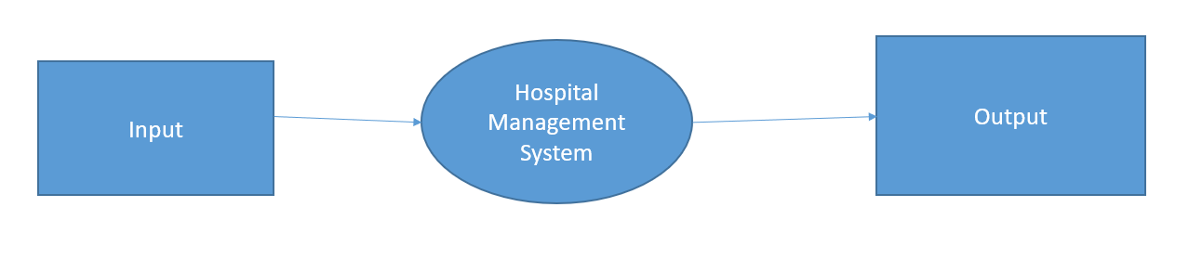

### LEVEL 2:

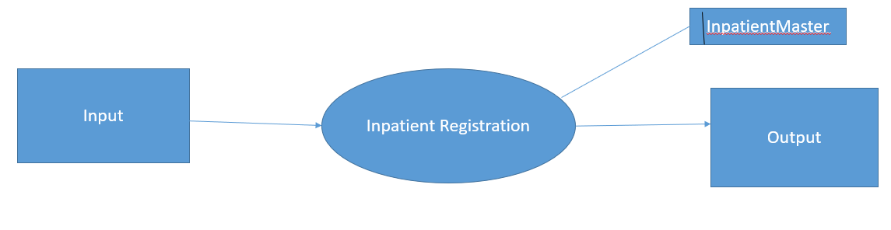

**ENTITY RELATIONSHIP DIAGRAM (ERD):**

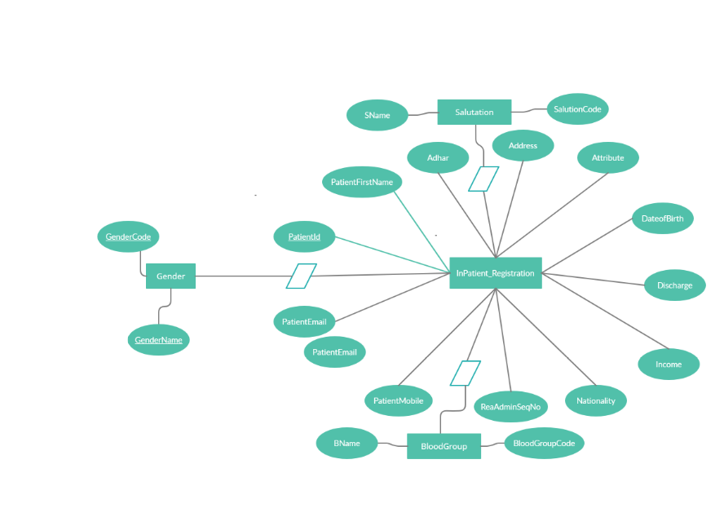

**3.2DATABASE DESIGN**

**INPATIENT_MASTER:**

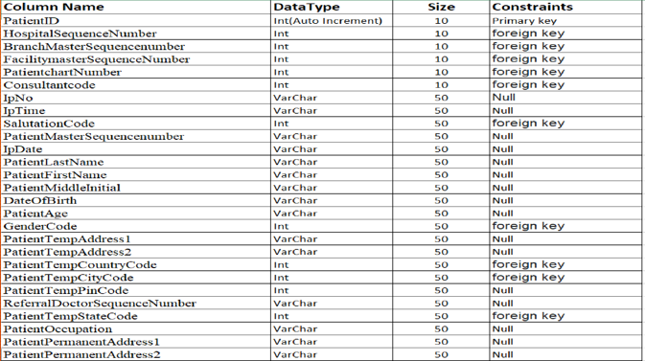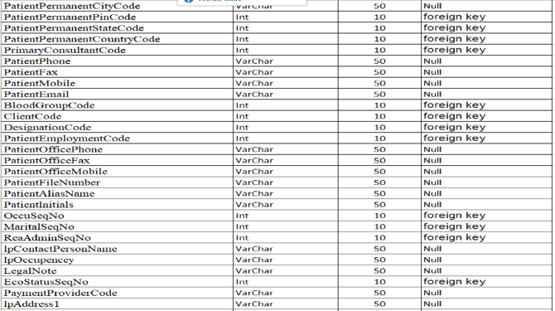

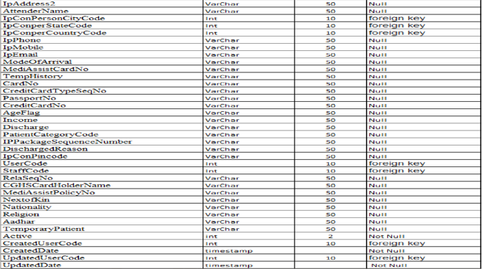

**3.3 GRAPHICAL USER INTERFACE (GUI) DESIGN:**

**PATIENT INFO:**

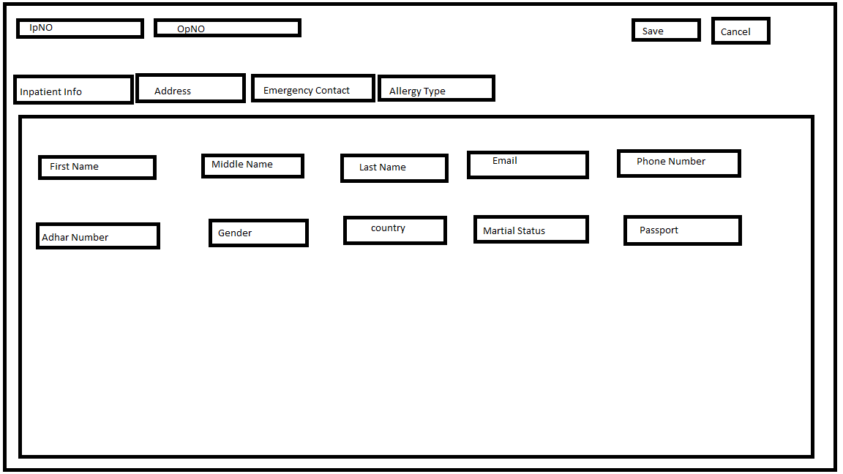

**IN PATIENT ADDRESS**:

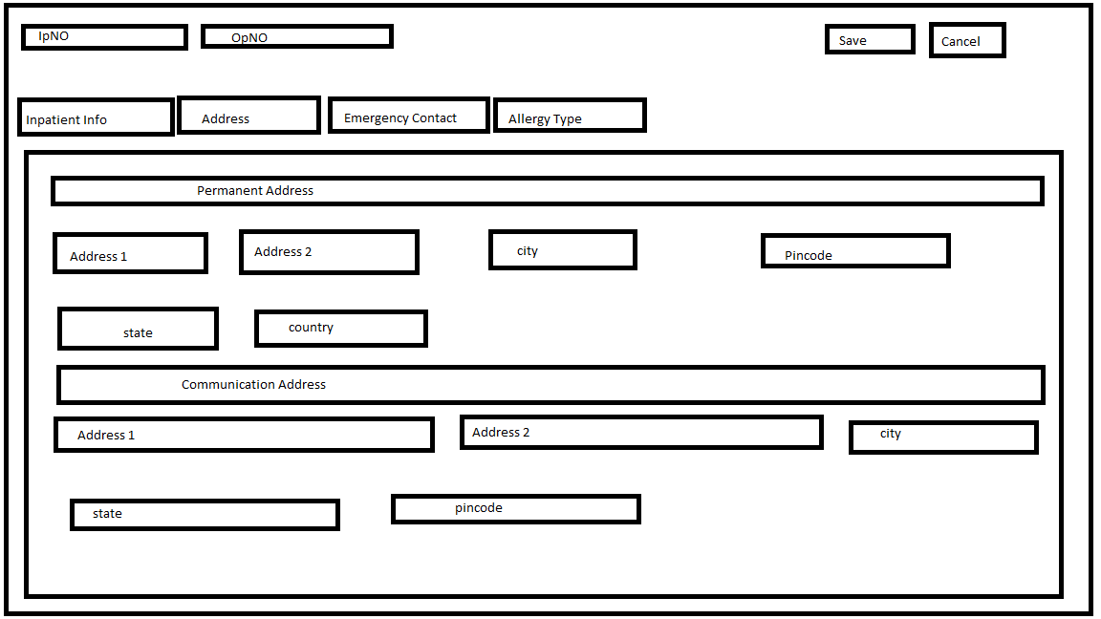

**EMERGENCY CONTACT:**

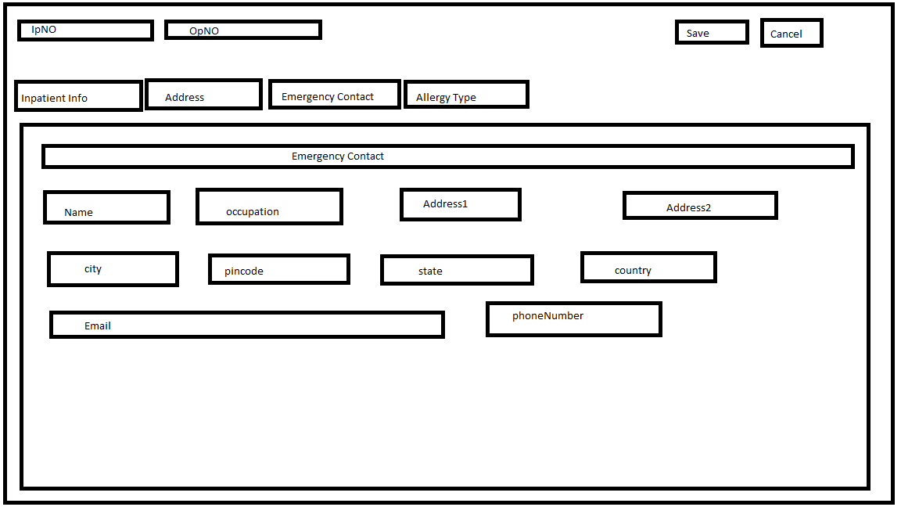

**ALLERGY TYPE:**

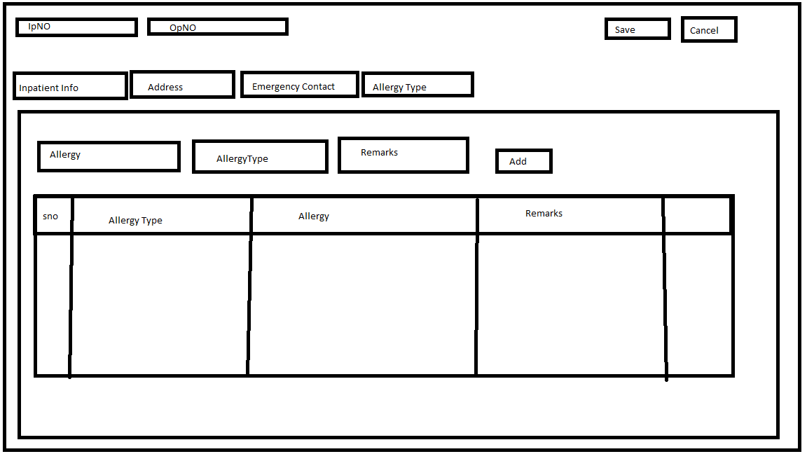

**CHAPTER 4**

**PROJECT DESCRIPTION**

There are four modules in the proposed system, which contains submodules used to audit the mall data’s. The below are key modules which are integrated in the project.

* + 1. Inpatient Registration
* In patient Registry
* In Patient Address
* Emergency Contact
* Allergy Type

**In Patient Registry:**

* In patient Registry
* In Patient Address
* Emergency Contact
* Allergy Type

Which is used to register the in-patients in order to admit the patients, In patient address is used to store their address in order to have a record, Emergency contact is used for patients in case of emergency, allergy type says which type of allergy it is.

### In Patient Registry:

In Patient Registry is used to admit the patients which contains their admission form include first name, last name, DOB, reason for admission, attender. Once the admission form is filled, it can be saved and the patient gets admitted.

### In Patient Address:

In patient Address is used to save the address of the patient containing fields as permanent address and temporary address in order to admit.

### Emergency Contact:

Emergency Contact is used to have the details of the patients attender in case of any emergency, containing certain fields as name, address, email id, pin code, phone no.

### Allery Type:

Allergy Type shows which type of allergy of the patient suffering from after checking the patient which is next to admission.

**Appointment Scheduling**:

In appointment scheduling we schedule the appointment for new patient in which we assign the date, time, department and doctor is available that time. If patient want particular doctor then we can search the doctors scheduling and available time for that doctor. Here we add the urgency and reminder to patient. We can also cancel the appointment of particular patient.

**Medoc** (Medical documentation and services):-

We can enter or view the previous medical record of particular patient. We can enter or view the prescription of particular patient. We can enter or view other information like : Notes and reports, Allergy, Diet Plan, Physician Orders, Problems, Measurement, Diagnosis, Therapy, Medical advice.

**Admission**:

In this module we can search the only admitted patient. Here we can update his details like prescription, notes and reports, measurement, birth details, pregnancies and we can cancel the particular admission.

# CHAPTER 5

## SYSTEM DEVELOPMENT

### LANGUAGE/ TOOL:

**.NET:**

The **.NET Framework** is a software development platform that was introduced by Microsoft in the late 1990 under the NGWS. On 13 February 2002, Microsoft launched the first version of the .NET Framework, referred to as the **.NET Framework 1.0**.

It is a virtual machine that provide a common platform to run an application that was built using the different language such as C#, VB.NET, Visual Basic, etc. It is also used to create a form based, console-based, mobile and web-based application or services that are available in Microsoft environment. Furthermore, the .NET framework is a pure object oriented, that similar to the Java language. But it is not a platform independent as the Java. So, its application runs only to the windows platform.

 CLR is the basic and Virtual Machine component of the .NET Framework. It is the run-time environment in the .NET Framework that runs the codes and helps in making the development process easier by providing the various services such as remoting, thread management, type-safety, memory management, robustness, etc.. Basically, it is responsible for managing the execution of .NET programs regardless of any .NET programming language. It also helps in the management of code, as code that targets the runtime is known as the Managed Code and code doesn’t target to runtime is known as Unmanaged code.

**Framework Class Library (FCL):** It is the collection of reusable, object-oriented class libraries and methods, etc that can be integrated with CLR. Also called the Assemblies. It is just like the header files in C/C++ and packages in the java. Installing .NET framework basically is the installation of CLR and FCL into the system. Below is the overview of .NET Framework.

### SQL SERVER:

It is just like the header files in C/C++ and packages in the java. Installing .NET framework basically is the installation of CLR and FCL into the system. Below is the overview of .NET Framework.

**SQL SERVER** is a relational database management system (RDBMS) developed by Microsoft. It is primarily designed and developed to complete with MySQL and Oracle database.

**SQL Server** supports ANSI SQL, which is the standard SQL (Structured Query Language). However, SQL server comes with its own implementation of the SQL language, T-SQL(Transact-SQL).

T-SQL is a Microsoft propriety language known as Transact-SQL. It provides further capabilities of declaring variable, exception handling, stored procedure, etc.

**SQL Server** Management Studio (SSMS) is the main interface tool for SQL Server, and its supports both 32-bit and 64-bit environments.

**SQL Server Enterprise:** It is used in the high end, large scale and mission Critical business. It provides High-end security, Advanced Analytics, Machine Learning.

**SQL Server Standard:** It is suitable for Mid-Tier Application and Data marts. It includes basic reporting and analytics.

**SQL Server WEB:** It is designed for a low total-cost-of-ownership option for Web host. It provides scalability, affordability, and manageability capabilities for small to large web properties.

**SQL Server Developer:** It is similar to an enterprise edition for the non-production environment. It is mainly used for build, test, and demo.

**SQL Server Express:** It is for small scale applications and free to use.

**5.2 PSEUDO CODE:**

### PATIENT:

Step1: Start.

Step 2: Enter Personal Details.

Step 4: Click to Patient Address Tab.

Step 5: Patient Address page is displayed.

Step 6: Stop.

### IN-PATIENT ADDRESS:

Step1: Start.

Step 2: Enter Permanent Address.

Step 3: Enter Communication Address.

Step 4: Click to Emergency Tab.

Step 5: Emergency Page is displayed.

Step 6: Stop.

### EMERGENCY CONTACT:

Step1: Start.

Step 2: Enter Emergency Contact Details.

Step 3: Click to Allery Type Tab.

Step 4: Allergy Type Page is displayed..

Step 5: Stop.

**ALLERY TYPE:**

Step1: Start.

Step 2: Choose Allergy.

Step 3: Choose Allergy Type.

Step 4: Add Some Remarks.

Step 5: Allergy will be Add.

Step 6: Edit Delete Allergy.

Step 7: Stop.

# CHAPTER 6

## SYSTEM TESTING AND VALIDATIONS

* + 1. **SYSTEM TESTING INTRODUCTION**

Software testing is a critical element of software quality assurance and represents the ultimate review of specification, design, and coding. In fact, testing is the one step in the software engineering process that could be viewed as destructive rather than constructive.

A strategy for software testing integrates software test case design methods into a well-planned series of steps that result in the successful construction of software. Testing is the set of activities that can be planned in advance and conducted systematically. The underlying motivation of program testing is to affirm software quality with methods that can economically and effectively apply both strategic to both large and small-scale systems.

## STRATEGIC APPROACH TO SOFTWARE TESTING

A strategy for software testing may also be viewed in the context of the spiral. Unit testing begins at the vertex of the spiral and concentrates on each unit of the software as implemented in source code. Testing progress is done by moving outward along the spiral to integration testing, where the focus is on the design and the construction of the software architecture. Talking another turn on outward on the spiral we encounter validation testing where requirements established as part of software requirements analysis are validated against the software that has been constructed. Finally, we arrive at system testing, where the software and other system elements are tested as a whole.

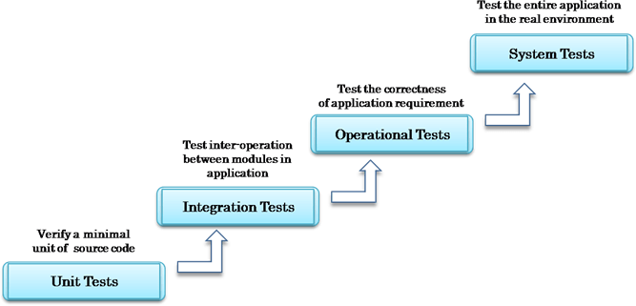

## UNIT TESTING

Unit Tests include sets of one or more programs which are designed to verify an atomic unit of source code, such as a method or a class.

An addition to Unit Testing is User Interface (UI) tests. These tests relate to UI components of your target application. UI tests ensure that your application return the correct UI output in response to sequence of user actions on device.

## INTEGRATION TESTING

In [Integration Testing,](https://www.guru99.com/integration-testing.html) all unit tested modules, are combined and verified. In Android, integration tests often involve checking integration with Android components such as Service testing, Activity testing, Content Provider testing, etc.

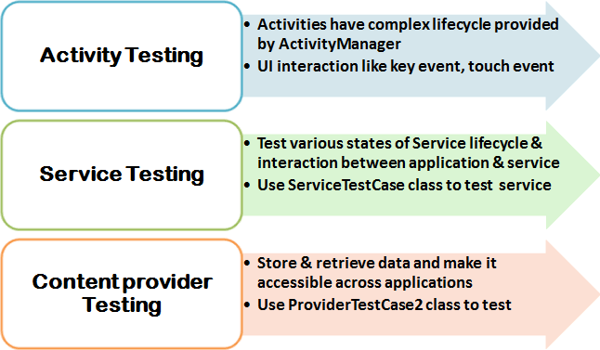

## OPERATIONAL TEST

Operational are also called functional tests or acceptation tests. They are high level tests designed to check the completeness and correctness of application.

## SYSTEM TEST

In system testing the system is tested as a whole and the interaction between the components, software and hardware is checked here.

## TEST CASES

|  |  |  |  |  |  |
| --- | --- | --- | --- | --- | --- |
| **Id** | **Scenario** | **Test Cases** | **Expected Result** | **Actual Result** | **Pass/Fail** |
| 1 | **IN- Patient Registry** | Enter correct data of all required field | It will accept the values. | It will accept and saved once it is saved. | Pass |
|  |  | Enter the text in pin code. | It will not accept the values. | It will display as it should contain integers. | Pass |
|  |  | Enter null values. | It will not accept the values. | It will display enter the required field. | Pass |
| 2 | **In patient address** | Enter correct data of required field. | It should show the values. | It will display the values. | Pass |
| Enter wrong data. | It should not show the values. | It will display enter the correct data. | Pass |
| If the values are null. | It should not show the values and result. | It will show the message of please fill out the field. | Pass |
| 3 | **Emergency contact** | If the values are null. | It should not display the values. | It should display please fill out this field. | Pass |
|  |  | If the values given are wrong. | It should not display the values. | It should display please fill out the correct format. | pass |
|  |  | If the given values are correct. | It will display the values. | It will display the values. | pass |
| 4 | **Allergy type** | If all the fields are filled. | It will display the values. | It will enable search button and once the action is performed the result will be displayed. | pass |
|  |  | If the fields are null values. | It will not display the values. | It will ask to fill the required field . | Pass |

* 1. **VALIDATIONS**

While verification is a quality control process, quality assurance process carried out before the software is ready for release is known as validation testing. The validation testing goals is to validate and be confident about the software product or systems, that it fulfils the requirements given by the user. The acceptance of the customer from the end customer is also a part of validation

Validation testing answers the question, “Are you building the right software”, another question which the entire process of validation testing in software engineering answers is, “Is the deliverable fit for the purpose”. In other words, does the software system provide the right solution to the problem? Therefore, often the testing activities are introduced early in the software development life cycle. The two major areas, when validation testing should take place are in the early stages of software development and towards the end when the product is ready for release.

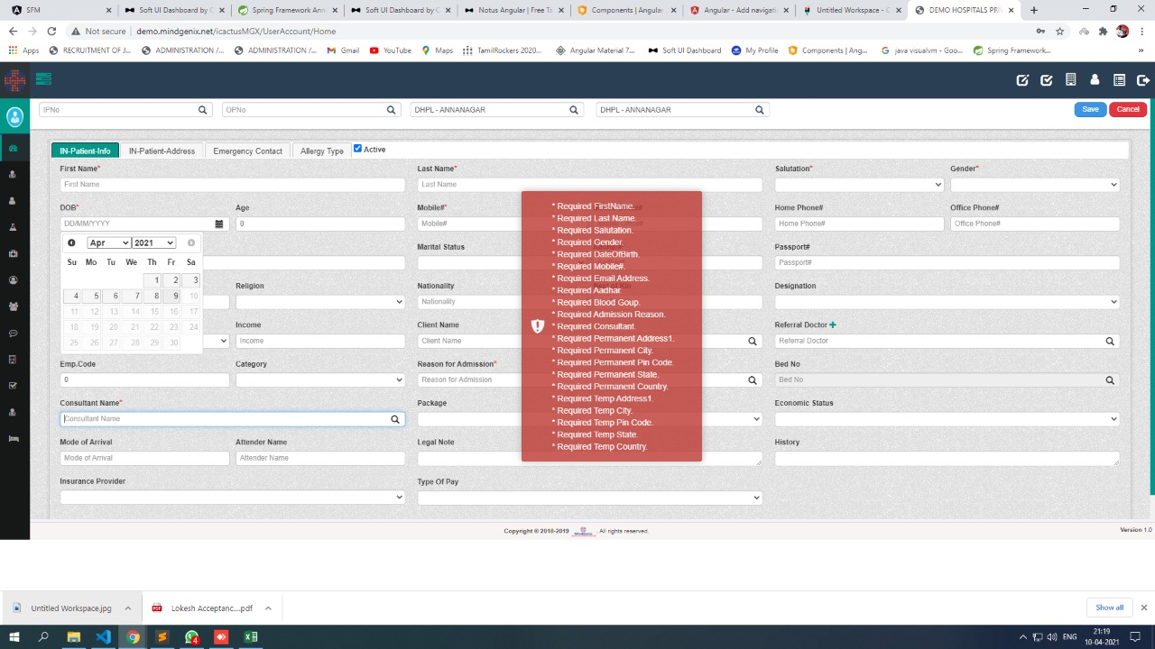

**CHAPTER 7**

**USER MANUAL**

**IN-PATIENT REGISTRATION:**

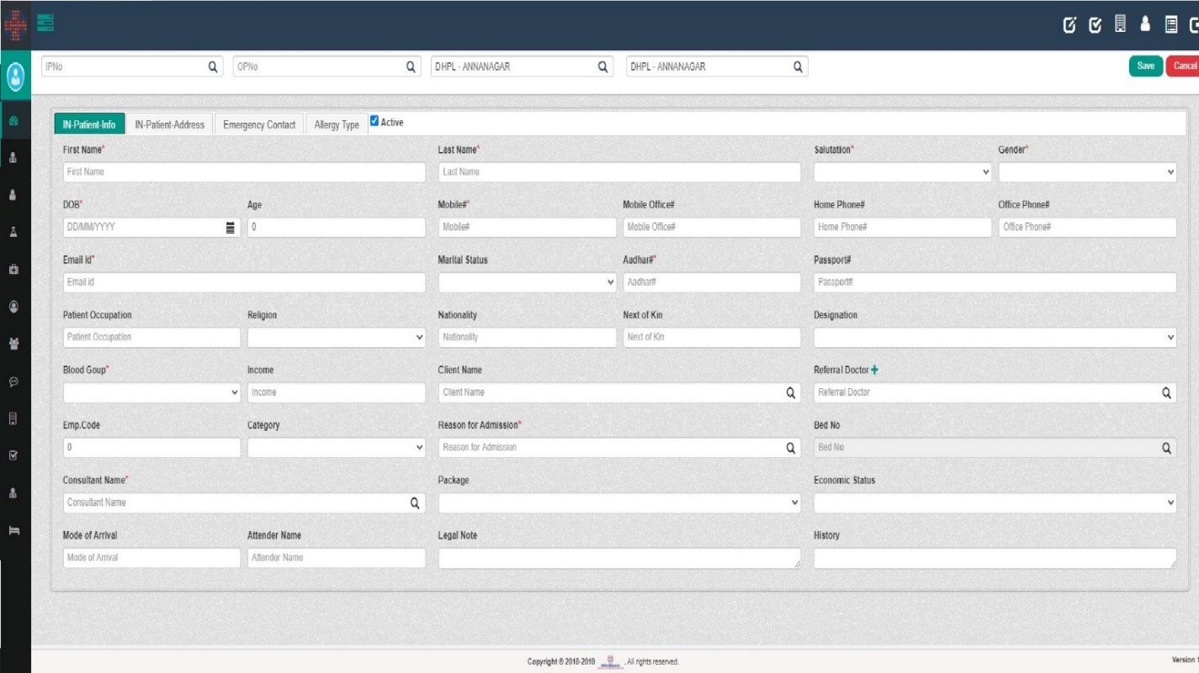

* + - Once the required particulars are given, the User can save it for the further use. It can be later viewed in the form of table. Search box is used to search the required field and textboxes are used to enter the text. Once it is filled it can be saved or either it can be cancelled.

## IN-PATIENT ADDRESS:

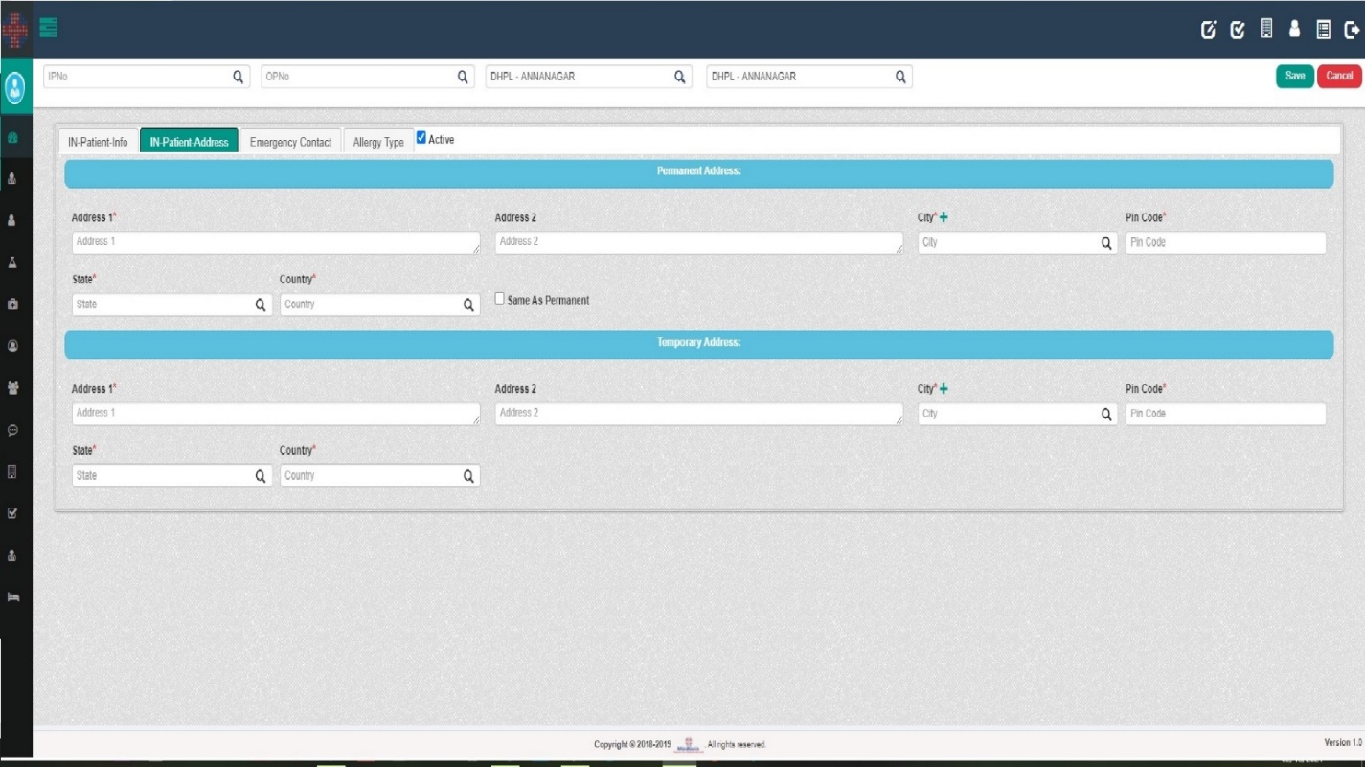

* + - The user can click on In-Patient Address to toggle from In-Patient Info. Address fields are required in order to save the details. Once the particulars are filled it can be saved for the future use.

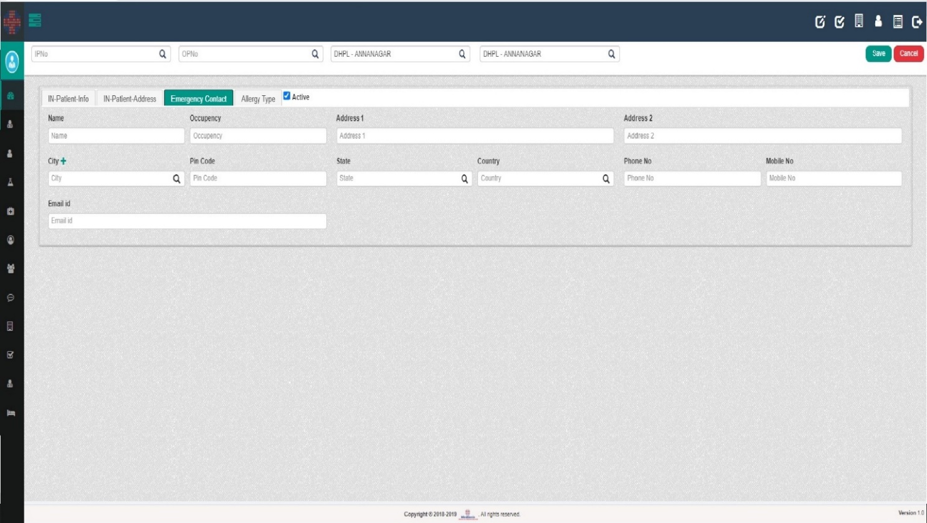

## The user can toggle from In-Patient Address to Emergency contact in order to use it. Required fields are to be filled. Once it is filled. It can be saved for further use.

## CHAPTER 8 SYSTEM IMPLEMENTATION

Implementation is the carrying out, execution, or practice of a plan, a method, or any design for doing something. As such, implementation is the action that must follow any preliminary thinking for something to happen. In an information technology context, implementation encompasses all the processes involved in getting new software or hardware operating properly in its environment, including installation, configuration, running, testing, and making necessary changes.

* This system is implemented by using **.NET** and **SQLSERVER.**
* .NET is a server-side web programming language that is widely used for web development.
* A implementation techniques involves the following steps:
* Visual studio code to write the coding.
* Installation of MySQL Management Studio server to connect the Backend SQLSERVER.

# MYSQL MANAGEMENT STUDIO

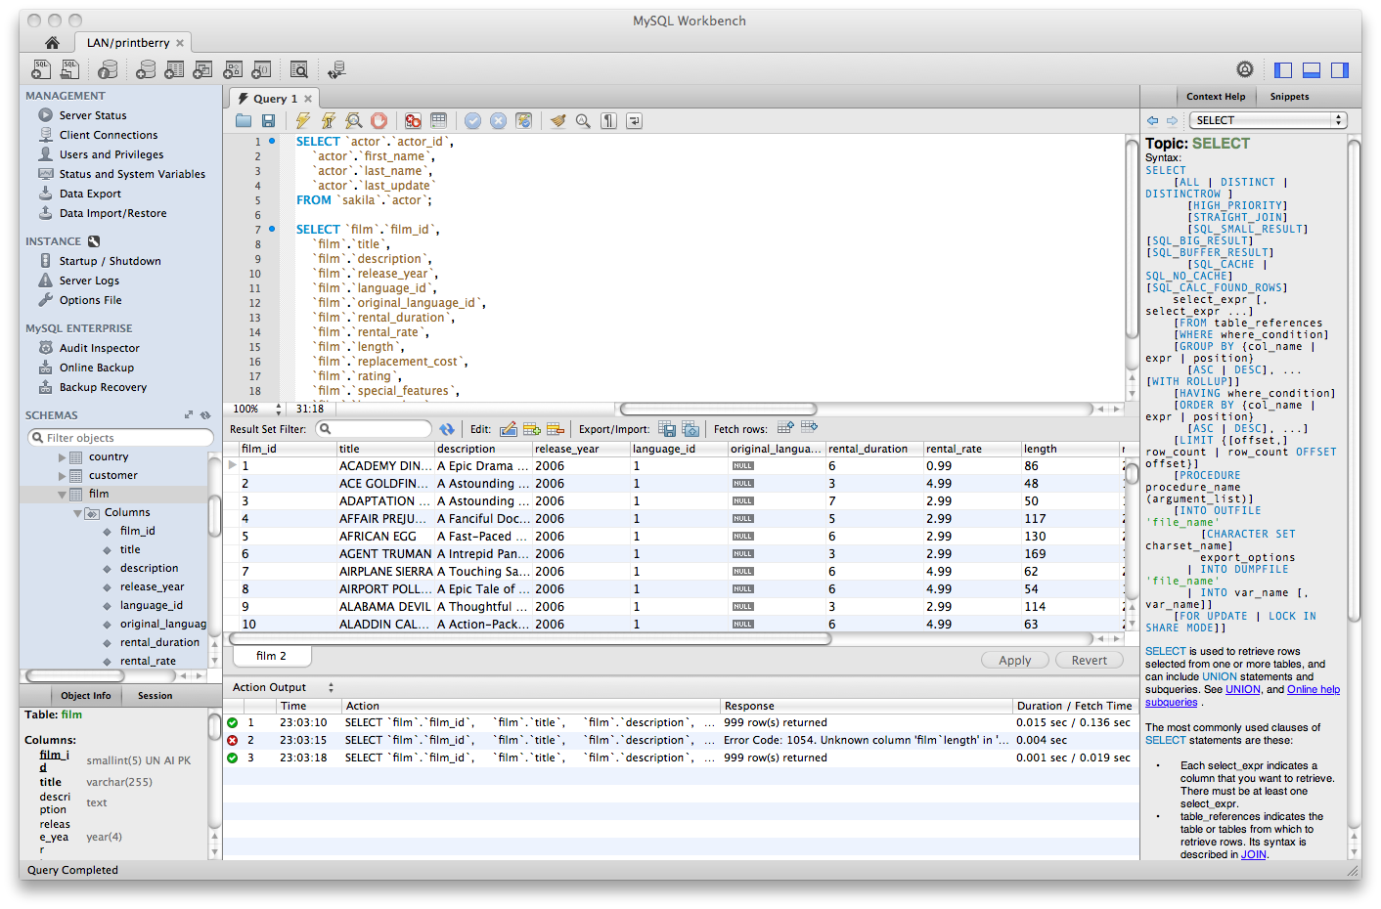

**Visual studio code:**

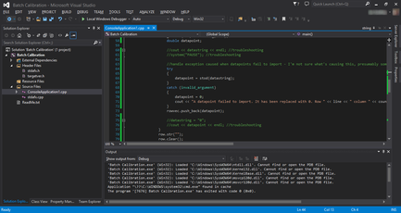

## CHAPTER 9 CONCLUSION

The project “**INPATIENT REGISTRY**” is for computerizing the working in a hospital. It is a great improvement over the manual system. The computerization of the system has speed up the process. In the current system, the front office managing is very slow. The hospital managing system was thoroughly checked and tested with dummy data and thus is found to be very reliable. The software takes care of all the requirements of an average hospital and is capable to provide easy and effective storage of information related to patients that come up to the hospital. It generates test reports and also provides the facility for searching the details of the patient. It also provides billing facility on the basis of patient’s status whether it is an indoor or outdoor patient. The system also provides the facility of backup as per the requirement.

# CHAPTER 10

## FUTURE ENHANCEMENT

The proposed system is **”INPATIENT REGISTRY”**. We can enhance this system by including more facilities like invoice can be generated for the patients to their mail. Invoices can also be generated by recording the voice so that it can be generated into text for report. Pharmacy billing can be generated and can include stock details of medicines in the pharmacy. Providing such features enable the users to include more comments into the system.

# CHAPTER 11

**BIBLIOGRAPHY**

**BOOK REFERENCES:**

1. Author: Dino Esposito.

Book: Programming .NET CORE,

Publication year: 2018.

1. Author: Andrew Lock.

Book: .NET Core in Action,

Publication year: 2018.

**WEB REFERENCES**

1. https://www.tutorialsteacher.com/mvc/asp.net-mvc-tutorials
2. https://www.w3schools.com
3. https://www.tutorialspoint.com/asp.net_mvc/index.h

# APPENDIX A-SAMPLE CODING

<div class="panel-body lobipanel-parent-sortable ui-sortable" id="DivPatientRegistrationBind" data-lobipanel-child-inner-id="rthUx0TljF">

<div class="panel panel-bd lobidrag lobipanel lobipanel-sortable" data-inner-id="rthUx0TljF" data-index="0">

<div id="tabs" class="ui-tabs ui-corner-all ui-widget ui-widget-content">

<ul role="tablist" class="ui-tabs-nav ui-corner-all ui-helper-reset ui-helper-clearfix ui-widget-header">

<li role="tab" tabindex="0" class="ui-tabs-tab ui-corner-top ui-state-default ui-tab ui-tabs-active ui-state-active active" aria-controls="tabPatientInfo" aria-labelledby="ui-id-1" aria-selected="true" aria-expanded="true"><a data-toggle="tab" href="#tabPatientInfo" role="presentation" tabindex="-1" class="ui-tabs-anchor" id="ui-id-1" aria-expanded="true">IN-Patient-Info</a></li>

<li role="tab" tabindex="-1" class="ui-tabs-tab ui-corner-top ui-state-default ui-tab" aria-controls="tabPatientAddress" aria-labelledby="ui-id-2" aria-selected="false" aria-expanded="false"><a data-toggle="tab" href="#tabPatientAddress" role="presentation" tabindex="-1" class="ui-tabs-anchor" id="ui-id-2" aria-expanded="false">IN-Patient-Address</a></li>

<li role="tab" tabindex="-1" class="ui-tabs-tab ui-corner-top ui-state-default ui-tab" aria-controls="tabEmergencyContact" aria-labelledby="ui-id-3" aria-selected="false" aria-expanded="false"><a data-toggle="tab" href="#tabEmergencyContact" role="presentation" tabindex="-1" class="ui-tabs-anchor" id="ui-id-3" aria-expanded="false">Emergency Contact</a></li>

<li role="tab" tabindex="-1" class="ui-tabs-tab ui-corner-top ui-state-default ui-tab" aria-controls="tabAllerigeType" aria-labelledby="ui-id-4" aria-selected="false" aria-expanded="false"><a data-toggle="tab" href="#tabAllerigeType" role="presentation" tabindex="-1" class="ui-tabs-anchor" id="ui-id-4">Allergy Type</a></li>

<div>

<input type="checkbox" name="Active" id="ChkActive" tabindex="71" checked="checked">

<label class="control-label">Active</label>

<input id="ObjIN_Patient_Active" name="ObjIN_Patient.Active" type="hidden" value="1">

</div>

</ul>

<div id="tabPatientInfo" aria-labelledby="ui-id-1" role="tabpanel" class="ui-tabs-panel ui-corner-bottom ui-widget-content active" aria-hidden="false" style="display: block;">

<div class="panel-body" style="padding:5px !important;">

<div class="col-sm-4">

<div class="col-sm-12 form-group">

<label class="control-label">First Name<span class="red">*</span></label>

<input class="form-control" id="ObjIN_Patient_PatientFirstName" name="ObjIN_Patient.PatientFirstName" placeholder="First Name" tabindex="4" type="text" value="">

<input id="ObjIN_Patient_IpDate" name="ObjIN_Patient.IpDate" type="hidden" value="">

<input id="ObjIN_Patient_IpTime" name="ObjIN_Patient.IpTime" type="hidden" value="">

</div>

<div class="col-sm-6 form-group">

<label class="control-label">DOB<span class="red">*</span></label>

<div class="inner-addon right-addon">

<i class="glyphicon glyphicon-calendar"></i>

<input class="form-control hasDatepicker" id="ObjIN_Patient_DateOfBirth" name="ObjIN_Patient.DateOfBirth" placeholder="DD/MM/YYYY" tabindex="8" type="text" value="">

</div>

</div>

<div class="col-sm-6 form-group">

<label class="control-label">Age</label>

<input class="form-control" data-val="true" data-val-number="The field PatientAge must be a number." data-val-required="The PatientAge field is required." id="ObjIN_Patient_PatientAge" name="ObjIN_Patient.PatientAge" placeholder="Age" tabindex="9" type="text" value="0">

</div>

<div class="col-sm-12 form-group">

<label class="control-label">Email id<span class="red">*</span></label>

<input class="form-control" id="ObjIN_Patient_PatientEmail" name="ObjIN_Patient.PatientEmail" placeholder="Email id" tabindex="14" type="text" value="">

</div>

<div class="col-sm-6 form-group">

<label class="control-label">Patient Occupation</label>

<input class="form-control" id="ObjIN_Patient_PatientOccupation" name="ObjIN_Patient.PatientOccupation" placeholder="Patient Occupation" tabindex="18" type="text" value="">

</div>

<div class="col-sm-6 form-group">

<label class="control-label">Religion</label>

<select class="form-control " id="ObjIN_Patient_Religion" name="ObjIN_Patient.Religion" tabindex="19"><option value=""></option>

<option value="1">HINDU</option>

<option value="2">MUSLIM</option>

<option value="3">CHRISTIAN</option>

<option value="4">SIKH</option>

<option value="5">BUDDHIST</option>

<option value="6">JAIN</option>

<option value="7">Others</option>

</select>

</div>

<div class="col-sm-6 form-group">

<label class="control-label">Blood Goup<span class="red">*</span></label>

<select class="form-control " data-val="true" data-val-number="The field BloodGroupCode must be a number." data-val-required="The BloodGroupCode field is required." id="ObjIN_Patient_BloodGroupCode" name="ObjIN_Patient.BloodGroupCode" tabindex="23"><option value=""></option>

<option value="1">A1+</option>

<option value="2">B +ve</option>

<option value="3">O +</option>

<option value="4">B -ve</option>

<option value="5">A -ve</option>

<option value="6">A +</option>

<option value="7">AB +v</option>

<option value="8">O -ve</option>

<option value="9">AB -v</option>

</select>

</div>

<div class="col-sm-6 form-group">

<label class="control-label">Income</label>

<input class="form-control" id="ObjIN_Patient_Income" name="ObjIN_Patient.Income" placeholder="Income" tabindex="24" type="number" value="">

</div>

<div class="col-sm-6 form-group">

<label class="control-label">Emp.Code</label>

<input class="form-control" data-val="true" data-val-number="The field PatientEmploymentCode must be a number." data-val-required="The PatientEmploymentCode field is required." id="ObjIN_Patient_PatientEmploymentCode" name="ObjIN_Patient.PatientEmploymentCode" placeholder="Emp.Code" tabindex="27" type="text" value="0">

</div>

<div class="col-sm-6 form-group">

<label class="control-label">Category</label>

<select class="form-control " data-val="true" data-val-number="The field PatientCategoryCode must be a number." data-val-required="The PatientCategoryCode field is required." id="ObjIN_Patient_PatientCategoryCode" name="ObjIN_Patient.PatientCategoryCode" tabindex="28"><option value=""></option>

<option value="1">FRONTIER</option>

<option value="2">SECOND OPINION</option>

<option value="3">CAMP</option>

<option value="4">SBOA</option>

<option value="5">DAV</option>

<option value="6">SALEM CAMP</option>

<option value="7">NABARD CAMP</option>

<option value="8">IDEA CAMP</option>

<option value="9">NELLORE CAMP</option>

<option value="10">PONDICHERRY CAMP</option>

<option value="11">SURAT CAMP</option>

<option value="12">TIRUPUR CAMP</option>

<option value="13">MUMBAI CAMP</option>

<option value="14">ASSAM</option>

<option value="15">RAJKOT CAMP</option>

<option value="16">SANGLI CAMP</option>

<option value="17">BANGALORE CAMP</option>

<option value="18">AHMEDABAD CAMP</option>

<option value="19">THENI CAMP</option>

<option value="20">TIRUNALVELLI CAMP</option>

<option value="21">SATHYAVEDU CAMP</option>

<option value="22">PATTUKOTTAI</option>

<option value="23">FIJI</option>

<option value="24">THITTACHERRY CAMP</option>

<option value="25">KARAIKAL CAMP</option>

<option value="26">THIRUVARUR CAMP</option>

<option value="27">POLICE CAMP</option>

<option value="28">VILLUPURAM CAMP</option>

<option value="29">SAIDAPET CAMP</option>

<option value="30">WEST BENGAL CAMP</option>

<option value="31">TUTICORIN CAMP</option>

<option value="32">KULASEKARA PATNAM</option>

<option value="33">ARKONAM CAMP</option>

<option value="34">ARCOT CAMP</option>

<option value="35">PANRUTI CAMP</option>

</select>

</div>

<div class="col-sm-12 form-group">

<label class="control-label">Consultant Name<span class="red">*</span></label>

<div class="inner-addon right-addon">

<i class="glyphicon glyphicon-search"></i>

<input class="form-control ui-autocomplete-input" id="ObjIN_Patient_ConsultantcodeCaption" name="ObjIN_Patient.ConsultantcodeCaption" placeholder="Consultant Name" tabindex="31" type="text" value="" autocomplete="off">

<input data-val="true" data-val-number="The field Consultantcode must be a number." data-val-required="The Consultantcode field is required." id="ObjIN_Patient_Consultantcode" name="ObjIN_Patient.Consultantcode" type="hidden" value="0">

</div>

</div>

<div class="col-sm-6 form-group">

<label class="control-label">Mode of Arrival</label>

<input class="form-control" id="ObjIN_Patient_ModeOfArrival" name="ObjIN_Patient.ModeOfArrival" placeholder="Mode of Arrival" tabindex="34" type="text" value="">

</div>

<div class="col-sm-6 form-group">

<label class="control-label">Attender Name</label>

<input class="form-control" id="ObjIN_Patient_AttenderName" name="ObjIN_Patient.AttenderName" placeholder="Attender Name" tabindex="35" type="text" value="">

</div>

<div class="col-sm-12 form-group">

<label class="control-label">Insurance Provider</label>

<select class="form-control" data-val="true" data-val-number="The field PatientInsuranceSequenceNumber must be a number." data-val-required="The PatientInsuranceSequenceNumber field is required." id="ObjIN_Patient_PatientInsuranceSequenceNumber" name="ObjIN_Patient.PatientInsuranceSequenceNumber" tabindex=""><option value=""></option>

<option value="40">Adithya Birla</option>

<option value="41">ADITYA BIRLA HEALTH INSURANCE CO.LIMITED</option>

<option value="22">Apollo DKV Insurance</option>

<option value="31">Apollo Munich Health Insurance Co. Ltd</option>

<option value="10">Bajaj Allianz General Insurance Co. Ltd</option>

<option value="19">Bharti AXA General Insurance Co</option>

<option value="11">Birla Sun Life Insurance Co. Ltd</option>

<option value="23">Cholamandalam MS General Insurance</option>

<option value="38">CIGNA TTK HEALTH INSURANCE CO. LTD</option>

<option value="42">DHFL General Insurance Co. Ltd</option>

<option value="45">EDELWEISS GENERAL INSURANCE COMPANY</option>

<option value="20">Future Generali Insurance Co. Ltd</option>

<option value="24">HDFC Ergo General Insurance Company</option>

<option value="12">HDFC Standard life Insurance Co. Ltd</option>

<option value="36">Hindustan Aeronautics Limited (HAL)</option>

<option value="29">HSBC Health Insurance Co. Ltd</option>

<option value="25">ICICI Lombard General Insurance</option>

<option value="21">IDBI Fortis Life Insurance</option>

<option value="26">IFFCO Tokio General Insurance</option>

<option value="43">Kotak Mahindra General insurance Co. Ltd.</option>

<option value="35">L AND T General Insurance Company Limited</option>

<option value="34">L AND T Ltd.</option>

<option value="46">LIBERTY GENERAL INSURANCE COMPANY</option>

<option value="37">LIBERTY VIDEOCON GENERAL INSURENCE</option>

<option value="13">Life Insurance Corporation of India</option>

<option value="14">Life Insurance Corporation of India</option>

<option value="44">MANIPALCIGNA HEALTH INSURANCE COMPANY LIMITED</option>

<option value="28">Max Bupa Health Insurance Co. Ltd</option>

<option value="15">Max New York Life Insurance Co. Ltd</option>

<option value="16">Met Life India Insurance Co. Ltd.</option>

<option value="2">National Insurance Co. Ltd.</option>

<option value="32">Nil</option>

<option value="3">Oriental Insurance Co. Ltd.</option>

<option value="27">Reliance General Insurance</option>

<option value="33">RELIGARE HEALTH INSURANCE</option>

<option value="5">Royal Sundaram Alliance Insurance</option>

<option value="39">SBI General Insurance Company Limited</option>

<option value="17">SBI Life Insurance Co. Ltd</option>

<option value="6">Shriram General Insurance Co. Ltd</option>

<option value="30">Star Health and Allied Insurance Co. Ltd</option>

<option value="7">Tata AIG General Insurance</option>

<option value="18">Tata AIG Life Insurance Co. Ltd.</option>

<option value="1">The New India Assurance Co. Ltd.</option>

<option value="4">United India Insurance Co. Ltd.</option>

<option value="8">United India Insurance Co. Ltd.</option>

<option value="9">Universal Sompo General Insurance Co. Ltd</option>

</select>

</div>

</div>

<div class="col-sm-4">

<div class="col-sm-12 form-group">

<label class="control-label">Last Name<span class="red">*</span></label>

<input class="form-control" id="ObjIN_Patient_PatientLastName" name="ObjIN_Patient.PatientLastName" placeholder="Last Name" tabindex="5" type="text" value="">

</div>

<div class="col-sm-6 form-group">

<label class="control-label">Mobile#<span class="red">*</span></label>

<input class="form-control" id="ObjIN_Patient_PatientMobile" maxlength="10" name="ObjIN_Patient.PatientMobile" placeholder="Mobile#" tabindex="10" type="text" value="">

</div>

<div class="col-sm-6 form-group">

<label class="control-label">Mobile Office#</label>

<input class="form-control" id="ObjIN_Patient_PatientOfficeMobile" maxlength="10" name="ObjIN_Patient.PatientOfficeMobile" placeholder="Mobile Office#" tabindex="11" type="text" value="">

</div>

<div class="col-sm-6 form-group">

<label class="control-label">Marital Status</label>

<select class="form-control " data-val="true" data-val-number="The field MaritalSeqNo must be a number." data-val-required="The MaritalSeqNo field is required." id="ObjIN_Patient_MaritalSeqNo" name="ObjIN_Patient.MaritalSeqNo" tabindex="15"><option value=""></option>

<option value="2">Married</option>

<option value="1">Single</option>

<option value="3">Unknown</option>

</select>

</div>

<div class="col-sm-6 form-group">

<label class="control-label">Aadhar#<span class="red">*</span></label>

<input class="form-control" id="ObjIN_Patient_Aadhar" maxlength="12" name="ObjIN_Patient.Aadhar" placeholder="Aadhar#" tabindex="16" type="text" value="">

</div>

<div class="col-sm-6 form-group">

<label class="control-label">Nationality</label>

<input class="form-control" id="ObjIN_Patient_Nationality" name="ObjIN_Patient.Nationality" placeholder="Nationality" tabindex="20" type="text" value="">

</div>

<div class="col-sm-6 form-group">

<label class="control-label">Next of Kin</label>

<input class="form-control" id="ObjIN_Patient_NextofKin" name="ObjIN_Patient.NextofKin" placeholder="Next of Kin" tabindex="21" type="text" value="">

</div>

<div class="col-sm-12 form-group">

<label class="control-label">Client Name</label>

<div class="inner-addon right-addon">

<i class="glyphicon glyphicon-search"></i>

<input class="form-control ui-autocomplete-input" id="ObjIN_Patient_ClientCodeCaption" name="ObjIN_Patient.ClientCodeCaption" placeholder="Client Name" tabindex="25" type="text" value="" autocomplete="off">

<input data-val="true" data-val-number="The field ClientCode must be a number." data-val-required="The ClientCode field is required." id="ObjIN_Patient_ClientCode" name="ObjIN_Patient.ClientCode" type="hidden" value="0">

</div>

</div>

<div class="col-sm-12 form-group">

<label class="control-label">Reason for Admission<span class="red">*</span></label>

<div class="inner-addon right-addon">

<i class="glyphicon glyphicon-search"></i>

<input class="form-control ui-autocomplete-input" id="ObjIN_Patient_ReaAdminSeqNoCaption" name="ObjIN_Patient.ReaAdminSeqNoCaption" placeholder="Reason for Admission" tabindex="29" type="text" value="" autocomplete="off">

<input data-val="true" data-val-number="The field ReaAdminSeqNo must be a number." data-val-required="The ReaAdminSeqNo field is required." id="ObjIN_Patient_ReaAdminSeqNo" name="ObjIN_Patient.ReaAdminSeqNo" type="hidden" value="0">

</div>

</div>

<div class="col-sm-12 form-group">

<label class="control-label">Package</label>

<select class="form-control " id="ObjIN_Patient_IPPackageSequenceNumber" name="ObjIN_Patient.IPPackageSequenceNumber" tabindex="32"><option value=""></option>

<option value="1">BYPASS SURGERY PRIVATE</option>

<option value="3">OPEN HEART SURGERY GENERAL</option>

</select>

</div>

<div class="col-sm-6 form-group" style="display:none;">

<label class="control-label">Credit Card</label>

<input class="form-control" id="ObjIN_Patient_CreditCardNo" maxlength="16" name="ObjIN_Patient.CreditCardNo" placeholder="Credit Card" tabindex="39" type="text" value="">

</div>

<div class="col-sm-12 form-group">

<label class="control-label">Legal Note</label>

<textarea class="form-control" cols="20" id="ObjIN_Patient_LegalNote" name="ObjIN_Patient.LegalNote" placeholder="" rows="2" style="line-height: 10px !important" tabindex="36" type="text"></textarea>

</div>

<div class="col-sm-12 form-group">

<label class="control-label">Type Of Pay</label>

<select class="form-control" data-val="true" data-val-number="The field PaymentProviderCode must be a number." data-val-required="The PaymentProviderCode field is required." id="ObjIN_Patient_PaymentProviderCode" name="ObjIN_Patient.PaymentProviderCode" tabindex=""><option value=""></option>

<option value="3">Cash</option>

<option value="1">Insurance</option>

<option value="2">Self Payment</option>

<option value="4">Smart Card</option>

</select>

</div>

</div>

<div class="col-sm-4">

<div class="col-sm-6 form-group">

<label class="control-label">Salutation<span class="red">*</span></label>

<select class="form-control " data-val="true" data-val-number="The field SalutationCode must be a number." data-val-required="The SalutationCode field is required." id="ObjIN_Patient_SalutationCode" name="ObjIN_Patient.SalutationCode" tabindex="6"><option value=""></option>

<option value="1"></option>

<option value="14">Adv</option>

<option value="26">Air Cmde</option>

<option value="16">Baby</option>

<option value="21">BRIGADIER</option>

<option value="4">Captain</option>

<option value="17">Col</option>

<option value="19">CPL</option>

<option value="8">Dr</option>

<option value="13">Er</option>

<option value="11">Fr</option>

<option value="20">Group captain</option>

<option value="23">Hon. Lt</option>

<option value="24">JUSTICE</option>

<option value="15">Lect</option>

<option value="25">Lt.</option>

<option value="5">Lt. Col</option>

<option value="18">Maj.</option>

<option value="27">Maj. General</option>

<option value="10">Master</option>

<option value="9">Miss</option>

<option value="2">Mr</option>

<option value="7">Mrs</option>

<option value="3">Ms</option>

<option value="6">Prof</option>

<option value="12">Sr</option>

<option value="22">Wg.Cdr</option>

</select>

</div>

<div class="col-sm-6 form-group">

<label class="control-label">Gender<span class="red">*</span></label>

<select class="form-control" data-val="true" data-val-number="The field GenderCode must be a number." data-val-required="The GenderCode field is required." id="ObjIN_Patient_GenderCode" name="ObjIN_Patient.GenderCode" tabindex="7"><option value=""></option>

<option value="3">Child</option>

<option value="2">Female</option>

<option value="1">Male</option>

<option value="4">Transgender</option>

</select>

</div>

<div class="col-sm-6 form-group">

<label class="control-label">Home Phone#</label>

<input class="form-control" id="ObjIN_Patient_PatientPhone" name="ObjIN_Patient.PatientPhone" placeholder="Home Phone#" tabindex="12" type="number" value="">

</div>

<div class="col-sm-6 form-group">

<label class="control-label">Office Phone#</label>

<input class="form-control" id="ObjIN_Patient_PatientOfficePhone" name="ObjIN_Patient.PatientOfficePhone" placeholder="Office Phone#" tabindex="13" type="number" value="">

</div>

<div class="col-sm-12 form-group">

<label class="control-label">Passport#</label>

<input class="form-control" id="ObjIN_Patient_PassportNo" maxlength="8" name="ObjIN_Patient.PassportNo" placeholder="Passport#" tabindex="17" type="text" value="">

</div>

<div class="col-sm-12 form-group">

<label class="control-label">Designation</label>

<select class="form-control" data-val="true" data-val-number="The field DesignationCode must be a number." data-val-required="The DesignationCode field is required." id="ObjIN_Patient_DesignationCode" name="ObjIN_Patient.DesignationCode" tabindex="22"><option value=""></option>

<option value="5">ADMIN</option>

<option value="31">BILLING EXECUTIVE</option>

<option value="32">BILLING MANAGER</option>

<option value="3">Doctor</option>

<option value="36">FRONT DESK EXECUTIVE</option>

<option value="35">FRONT DESK MANAGER</option>

<option value="33">IT EXECUTIVE</option>

<option value="17">LAB ASSISTANT</option>

<option value="18">MARKETING EXECUTIVE</option>

<option value="2">NURSE</option>

<option value="6">OPD CO ORDINATOR</option>

<option value="38">OPTICALS EXECUTIVE</option>

<option value="39">OPTICALS MANAGER</option>

<option value="37">Optometrist</option>

<option value="24">STORES</option>

<option value="40">Students</option>

<option value="4">SURGICAL CO CORDINATOR</option>

</select>

</div>

<div class="col-sm-12 form-group">

<label class="control-label">

Referral Doctor

<i class="glyphicon glyphicon-plus pointer-cursor" style="color:#029587" data-toggle="modal" id="PMReferDoctormodel" data-target="#ReferDoctormodel"></i>

</label>

<div class="inner-addon right-addon">

<i class="glyphicon glyphicon-search"></i>

<input class="form-control ui-autocomplete-input" id="ObjIN_Patient_ReferralDoctorSequenceNumberCaption" name="ObjIN_Patient.ReferralDoctorSequenceNumberCaption" placeholder="Referral Doctor" tabindex="26" type="text" value="" autocomplete="off">

<input data-val="true" data-val-number="The field ReferralDoctorSequenceNumber must be a number." data-val-required="The ReferralDoctorSequenceNumber field is required." id="ObjIN_Patient_ReferralDoctorSequenceNumber" name="ObjIN_Patient.ReferralDoctorSequenceNumber" type="hidden" value="0">

</div>

</div>

<div class="col-sm-12 form-group">

<label class="control-label">Bed No</label>

<div class="inner-addon right-addon">

<i class="glyphicon glyphicon-search"></i>

<input class="form-control" disabled="True" id="ObjIPPatientBed_t_RegularTemp_c" name="ObjIPPatientBed_t.RegularTemp_c" placeholder="Bed No" tabindex="30" type="text" value="">

</div>

</div>

<div class="col-sm-12 form-group">

<label class="control-label">Economic Status</label>

<select class="form-control " data-val="true" data-val-number="The field EcoStatusSeqNo must be a number." data-val-required="The EcoStatusSeqNo field is required." id="ObjIN_Patient_EcoStatusSeqNo" name="ObjIN_Patient.EcoStatusSeqNo" tabindex="33"><option value=""></option>

<option value="105">-BLANK-</option>

<option value="101">Lower</option>

<option value="101">LowerMiddle</option>

<option value="102">Middle</option>

<option value="104">Upper Middle</option>

</select>

</div>

<div class="col-sm-6 form-group" style="display:none;">

<label class="control-label">Card Type</label>

<select class="form-control " data-val="true" data-val-number="The field CreditCardTypeSeqNo must be a number." data-val-required="The CreditCardTypeSeqNo field is required." id="ObjIN_Patient_CreditCardTypeSeqNo" name="ObjIN_Patient.CreditCardTypeSeqNo" tabindex="34"><option value=""></option>

<option value="5">AXIS</option>

<option value="2">HDFC</option>

<option value="1">ICICI</option>

<option value="3">KOTAK </option>

<option value="4">SBI</option>

</select>

</div>

<div class="col-sm-6 form-group" style="display:none;">

<label class="control-label">Payment Provider</label>

<select class="form-control " id="ObjIN_Patient_PaymentProviderCode" name="ObjIN_Patient.PaymentProviderCode" tabindex="35"><option value=""></option>

<option value="51">ABBEY NATIONAL</option>

<option value="25">ABN-AMRO BANK</option>

<option value="56">AFFINITY</option>

<option value="22">AMANATH CO-OP. BANK LIMITED</option>

<option value="1">American Experss</option>

<option value="99">ANDHRA BANK</option>

<option value="115">ARTHA</option>

<option value="84">AT&amp;T UNIVERSAL PLATINUM</option>

<option value="116">AXIS BANK</option>

<option value="85">BANGALORE SOUHARDHA CENTRAL CO-OP BANK LTD</option>

<option value="79">BANK OF AMERICA</option>

<option value="29">BANK OF BARODA</option>

<option value="71">BANK OF CHINA</option>

<option value="4">BANK OF INDIA</option>

<option value="55">BARCLAYCARD</option>

<option value="13">BSNL</option>

<option value="15">CANARA BANK</option>

<option value="31">CANCARD</option>

<option value="89">CAPITAL ONE</option>

<option value="62">CENTRAL BANK OF INDIA</option>

<option value="105">CENTURION BANK</option>

<option value="19">CITI BANK</option>

<option value="70">COLUMBIA TRUST BANK</option>

<option value="17">COMPASS BANK</option>

<option value="37">CORPORATION BANK</option>

<option value="61">DCU VISA GOLD</option>

<option value="65">DEEPAK SAHAKARI BANL LTD</option>

<option value="77">DUBAI BANK</option>

<option value="113">ECHS</option>

<option value="24">FHPL</option>

<option value="74">FIRST UNION</option>

<option value="75">FLEET</option>

<option value="50">GAURDIAN SOUHARDA BANK</option>

<option value="86">GE CASH ACCESS</option>

<option value="58">GENINS</option>

<option value="93">GLOBAL TRUST BANK</option>

<option value="88">HALIFAX</option>

<option value="7">HDFC BANK</option>

<option value="23">HSBC</option>

<option value="3">ICICI</option>

<option value="69">IDBI BANK</option>

<option value="40">INDIAN BANK</option>

<option value="5">INDIAN OVERSEAS BANK</option>

<option value="39">ING VYSYA BANK</option>

<option value="102">KAR ST CO-OP APEX BANK LTD</option>

<option value="44">KARNATAKA BANK</option>

<option value="108">LORD KRISHNA BANK PVT LTD</option>

<option value="103">MAHILA CO-OPERATIVE BANK LTD</option>

<option value="94">MANHATTAN</option>

<option value="117">MASTER</option>

<option value="97">MASTREO</option>

<option value="16">MEDIASSIST INDIA PVT LTD</option>

<option value="28">MEDICARE</option>

<option value="12">MEDSAVE</option>

<option value="34">NAL</option>

<option value="66">NATIONAL BANK OF DUBAI</option>

<option value="110">NATIONAL CO-OP BANK</option>

<option value="87">NATWEST</option>

<option value="30">NEW INDIA ASSURANCE CO.</option>

<option value="95">NORDEA</option>

<option value="107">OMAN INTERNATIONAL BANK</option>

<option value="73">ORIENTAL BANK OF COMMERCE</option>

<option value="35">OTHERS</option>

<option value="53">POST OFFICE SAVINGS BANK</option>

<option value="90">PUNJAB NATIONAL BANK</option>

<option value="9">RESERVE BANK OF INDIA</option>

<option value="36">RUPAY</option>

<option value="60">SHAMRT CO-OP.BANK LTD</option>

<option value="43">SREE THYAGARAJA CO-OPERATIVE BANK LTD</option>

<option value="2">Standed Charted</option>

<option value="18">STATE BANK OF HYDERABAD</option>

<option value="10">STATE BANK OF INDIA</option>

<option value="8">STATE BANK OF MYSORE</option>

<option value="81">STATE BANK OF SAURASHTRA</option>

<option value="54">STATE BANK OF TRAVANCORE</option>

<option value="96">SWISS TRAVEL CLUB</option>

<option value="20">SYNDICATE BANK</option>

<option value="57">TECH-CU</option>

<option value="112">THE KARUR VYSYA BANK LTD</option>

<option value="100">THE LAKSHMI VILAS BANK LTD</option>

<option value="41">THE MALLESWARAM CO-OPERATIVE BANK LTD</option>

<option value="82">THE SAUDI BRITISH BANK</option>

<option value="72">THE SHAMRAO VITHAL CO-OP BANK LTD.</option>

<option value="111">THE SOUTH INDIAN BANK LTD.</option>

<option value="92">TIMES CARD</option>

<option value="6">TTK HEALTHCARE SERVICES</option>

<option value="33">UBI</option>

<option value="46">UCO BANK</option>

<option value="27">UHC</option>

<option value="83">UNION BANK OF INDIA</option>

<option value="98">UNITED AIRLINES</option>

<option value="48">UNITED INDIA INSURANCE COMPANY LTD</option>

<option value="76">UNITED MILEAGE PLUS</option>

<option value="109">URBAN CO-OP CRE SOCIETY LTD</option>

<option value="91">US CREDIT UNION</option>

<option value="59">US-AIRWAYS</option>

<option value="32">UTI BANK</option>

<option value="26">V-CO-OP-BANK</option>

<option value="80">VERIZON</option>

<option value="21">VIJAYA BANK</option>

<option value="78">VISA</option>

<option value="63">VISA CLASSIC</option>

<option value="104">VYSYA CO-OPERATIVE BANK LTD</option>

<option value="68">WELLS FARGO</option>

</select>

</div>

<div class="col-sm-12 form-group">

<label class="control-label">History</label>

<textarea class="form-control" cols="20" id="ObjIN_Patient_TempHistory" name="ObjIN_Patient.TempHistory" placeholder="" rows="2" style="line-height: 10px !important" tabindex="37" type="text"></textarea>

</div>

</div>

</div>

</div>

<div id="tabPatientAddress" aria-labelledby="ui-id-2" role="tabpanel" class="ui-tabs-panel ui-corner-bottom ui-widget-content" aria-hidden="true" style="display: none;">

<div class="panel-body" style="padding:5px !important;">

<div class="col-sm-12">

<div class="col-sm-12 btn btn-info">

<label class="control-label">Permanent Address:</label>

</div>

<br>

</div>

<div class="col-sm-12">

<br>

<div class="col-sm-4">

<div class="col-sm-12 form-group">

<label class="control-label">Address 1<span class="red">*</span></label>

<textarea class="form-control" cols="20" id="ObjIN_Patient_PatientPermanentAddress1" name="ObjIN_Patient.PatientPermanentAddress1" placeholder="Address 1" rows="2" style="height:25px;" tabindex="44" type="text"></textarea>

</div>

<div class="col-sm-6 form-group">

<label class="control-label">State<span class="red">*</span></label>

<div class="inner-addon right-addon">

<i class="glyphicon glyphicon-search"></i>

<input class="form-control ui-autocomplete-input" id="ObjIN_Patient_PatientPermanentStatCodeCaption" name="ObjIN_Patient.PatientPermanentStatCodeCaption" placeholder="State" tabindex="48" type="text" value="" autocomplete="off">

<input data-val="true" data-val-number="The field PatientPermanentStateCode must be a number." data-val-required="The PatientPermanentStateCode field is required." id="ObjIN_Patient_PatientPermanentStateCode" name="ObjIN_Patient.PatientPermanentStateCode" type="hidden" value="0">

</div>

</div>

<div class="col-sm-6 form-group">

<label class="control-label">Country<span class="red">*</span></label>

<div class="inner-addon right-addon">

<i class="glyphicon glyphicon-search"></i>

<input class="form-control ui-autocomplete-input" id="ObjIN_Patient_PatientPermanentCountryCodeCaption" name="ObjIN_Patient.PatientPermanentCountryCodeCaption" placeholder="Country" tabindex="49" type="text" value="" autocomplete="off">

<input data-val="true" data-val-number="The field PatientPermanentCountryCode must be a number." data-val-required="The PatientPermanentCountryCode field is required." id="ObjIN_Patient_PatientPermanentCountryCode" name="ObjIN_Patient.PatientPermanentCountryCode" type="hidden" value="0">

</div>

</div>

</div>

<div class="col-sm-4">

<div class="col-sm-12 form-group">

<label class="control-label">Address 2</label>

<textarea class="form-control" cols="20" id="ObjIN_Patient_PatientPermanentAddress2" name="ObjIN_Patient.PatientPermanentAddress2" placeholder="Address 2" rows="2" style="height:25px;" tabindex="45" type="text"></textarea>

</div>

<div class="col-sm-6">

<br>

<input type="checkbox" tabindex="36" id="ChkSameAsPermanent" name="Permanent" onclick="Tempaddr();" value="Permanent">

<label class="control-label">Same As Permanent</label>

</div>

</div>

<div class="col-sm-4">

<div class="col-sm-6 form-group">

<label class="control-label">

City<span class="red">*</span>

<i class="glyphicon glyphicon-plus pointer-cursor" style="color:#029587" data-toggle="modal" id="PMCity" data-target="#Citymodel"></i>

</label>

<div class="inner-addon right-addon">

<i class="glyphicon glyphicon-search"></i>

<input class="form-control ui-autocomplete-input" id="ObjIN_Patient_PatientPermanentCityCaption" name="ObjIN_Patient.PatientPermanentCityCaption" placeholder="City" tabindex="46" type="text" value="" autocomplete="off">

<input data-val="true" data-val-number="The field PatientPermanentCityCode must be a number." data-val-required="The PatientPermanentCityCode field is required." id="ObjIN_Patient_PatientPermanentCityCode" name="ObjIN_Patient.PatientPermanentCityCode" type="hidden" value="0">

</div>

</div>

<div class="col-sm-6 form-group">

<label class="control-label">Pin Code<span class="red">*</span></label>

<input class="form-control" id="ObjIN_Patient_PatientPermanentPinCode" maxlength="6" name="ObjIN_Patient.PatientPermanentPinCode" placeholder="Pin Code" tabindex="47" type="text" value="">

</div>

</div>

</div>

<div class="col-sm-12">

<div class="col-sm-12 btn btn-info">

<label class="control-label">Temporary Address:</label>

</div>

<br>

</div>

<div class="col-sm-12">

<br>

<div class="col-sm-4">

<div class="col-sm-12 form-group">

<label class="control-label">Address 1<span class="red">*</span></label>

<textarea class="form-control" cols="20" id="ObjIN_Patient_PatientTempAddress1" name="ObjIN_Patient.PatientTempAddress1" placeholder="Address 1" rows="2" style="height:25px;" tabindex="50" type="text"></textarea>

</div>

<div class="col-sm-6 form-group">

<label class="control-label">State<span class="red">*</span></label>

<div class="inner-addon right-addon">

<i class="glyphicon glyphicon-search"></i>

<input class="form-control ui-autocomplete-input" id="ObjIN_Patient_PatientTempStateNameCaption" name="ObjIN_Patient.PatientTempStateNameCaption" placeholder="State" tabindex="54" type="text" value="" autocomplete="off">

<input data-val="true" data-val-number="The field PatientTempStateCode must be a number." data-val-required="The PatientTempStateCode field is required." id="ObjIN_Patient_PatientTempStateCode" name="ObjIN_Patient.PatientTempStateCode" type="hidden" value="0">

</div>

</div>

<div class="col-sm-6 form-group">

<label class="control-label">Country<span class="red">*</span></label>

<div class="inner-addon right-addon">

<i class="glyphicon glyphicon-search"></i>

<input class="form-control ui-autocomplete-input" id="ObjIN_Patient_PatientTempCountryCodeCaption" name="ObjIN_Patient.PatientTempCountryCodeCaption" placeholder="Country" tabindex="55" type="text" value="" autocomplete="off">

<input data-val="true" data-val-number="The field PatientTempCountryCode must be a number." data-val-required="The PatientTempCountryCode field is required." id="ObjIN_Patient_PatientTempCountryCode" name="ObjIN_Patient.PatientTempCountryCode" type="hidden" value="0">

</div>

</div>

</div>

<div class="col-sm-4">

<div class="col-sm-12 form-group">

<label class="control-label">Address 2</label>

<textarea class="form-control" cols="20" id="ObjIN_Patient_PatientTempAddress2" name="ObjIN_Patient.PatientTempAddress2" placeholder="Address 2" rows="2" style="height:25px;" tabindex="51" type="text"></textarea>

</div>

</div>

<div class="col-sm-4">

<div class="col-sm-6 form-group">

<label class="control-label">

City<span class="red">*</span>

<i class="glyphicon glyphicon-plus pointer-cursor" style="color:#029587" data-toggle="modal" id="PMCity" data-target="#Citymodel"></i>

</label>

<div class="inner-addon right-addon">

<i class="glyphicon glyphicon-search"></i>

<input class="form-control ui-autocomplete-input" id="ObjIN_Patient_PatientTempCityCaption" name="ObjIN_Patient.PatientTempCityCaption" placeholder="City" tabindex="52" type="text" value="" autocomplete="off">

<input data-val="true" data-val-number="The field PatientTempCityCode must be a number." data-val-required="The PatientTempCityCode field is required." id="ObjIN_Patient_PatientTempCityCode" name="ObjIN_Patient.PatientTempCityCode" type="hidden" value="0">

</div>

</div>

<div class="col-sm-6 form-group">

<label class="control-label">Pin Code<span class="red">*</span></label>

<input class="form-control" id="ObjIN_Patient_PatientTempPinCode" maxlength="6" name="ObjIN_Patient.PatientTempPinCode" placeholder="Pin Code" tabindex="53" type="text" value="">

</div>

</div>

</div>

</div>

</div>

<div id="tabEmergencyContact" aria-labelledby="ui-id-3" role="tabpanel" class="ui-tabs-panel ui-corner-bottom ui-widget-content" aria-hidden="true" style="display: none;">

<div class="panel-body" style="padding:5px !important;">

<div class="col-sm-4">

<div class="col-sm-6 form-group">

<label class="control-label">Name</label>

<input class="form-control" id="ObjIN_Patient_IpContactPersonName" name="ObjIN_Patient.IpContactPersonName" placeholder="Name" tabindex="56" type="text" value="">

</div>

<div class="col-sm-6 form-group">

<label class="control-label">Occupency</label>

<input class="form-control" id="ObjIN_Patient_IpOccupencey" name="ObjIN_Patient.IpOccupencey" placeholder="Occupency" tabindex="57" type="text" value="">

</div>

<div class="col-sm-6 form-group">

<label class="control-label">

City

<i class="glyphicon glyphicon-plus pointer-cursor" style="color:#029587" data-toggle="modal" id="PMCity" data-target="#Citymodel"></i>

</label>

<div class="inner-addon right-addon">

<i class="glyphicon glyphicon-search"></i>

<input class="form-control ui-autocomplete-input" id="ObjIN_Patient_IpConPersonCityCaption" name="ObjIN_Patient.IpConPersonCityCaption" placeholder="City" tabindex="60" type="text" value="" autocomplete="off">

<input data-val="true" data-val-number="The field IpConPersonCityCode must be a number." data-val-required="The IpConPersonCityCode field is required." id="ObjIN_Patient_IpConPersonCityCode" name="ObjIN_Patient.IpConPersonCityCode" type="hidden" value="0">

</div>

</div>

<div class="col-sm-6 form-group">

<label class="control-label">Pin Code</label>

<input class="form-control" id="ObjIN_Patient_IpConPincode" maxlength="6" name="ObjIN_Patient.IpConPincode" placeholder="Pin Code" tabindex="61" type="text" value="">

</div>

<div class="col-sm-12 form-group">

<label class="control-label">Email id</label>

<input class="form-control" id="ObjIN_Patient_IpEmail" name="ObjIN_Patient.IpEmail" placeholder="Email id" tabindex="66" type="text" value="">

</div>

</div>

<div class="col-sm-4">

<div class="col-sm-12 form-group">

<label class="control-label">Address 1</label>

<input class="form-control" id="ObjIN_Patient_IpAddress1" name="ObjIN_Patient.IpAddress1" placeholder="Address 1" tabindex="58ss" type="text" value="">

</div>

<div class="col-sm-6 form-group">

<label class="control-label">

State

</label>

<div class="inner-addon right-addon">

<i class="glyphicon glyphicon-search"></i>

<input class="form-control ui-autocomplete-input" id="ObjIN_Patient_IpConperStateCaption" name="ObjIN_Patient.IpConperStateCaption" placeholder="State" tabindex="62" type="text" value="" autocomplete="off">

<input data-val="true" data-val-number="The field IpConperStateCode must be a number." data-val-required="The IpConperStateCode field is required." id="ObjIN_Patient_IpConperStateCode" name="ObjIN_Patient.IpConperStateCode" type="hidden" value="0">

</div>

</div>

<div class="col-sm-6 form-group">

<label class="control-label">

Country

</label>

<div class="inner-addon right-addon">

<i class="glyphicon glyphicon-search"></i>

<input class="form-control ui-autocomplete-input" id="ObjIN_Patient_IpConperCountryCaption" name="ObjIN_Patient.IpConperCountryCaption" placeholder="Country" tabindex="63" type="text" value="" autocomplete="off">

<input data-val="true" data-val-number="The field IpConperCountryCode must be a number." data-val-required="The IpConperCountryCode field is required." id="ObjIN_Patient_IpConperCountryCode" name="ObjIN_Patient.IpConperCountryCode" type="hidden" value="0">

</div>

</div>

</div>

<div class="col-sm-4">

<div class="col-sm-12 form-group">

<label class="control-label">Address 2</label>

<input class="form-control" id="ObjIN_Patient_IpAddress2" name="ObjIN_Patient.IpAddress2" placeholder="Address 2" tabindex="59" type="text" value="">

</div>

<div class="col-sm-6 form-group">

<label class="control-label">Phone No</label>

<input class="form-control" id="ObjIN_Patient_IpPhone" maxlength="10" name="ObjIN_Patient.IpPhone" placeholder="Phone No" tabindex="64" type="text" value="">

</div>

<div class="col-sm-6 form-group">

<label class="control-label">Mobile No</label>

<input class="form-control" id="ObjIN_Patient_IpMobile" maxlength="10" name="ObjIN_Patient.IpMobile" placeholder="Mobile No" tabindex="65" type="text" value="">

</div>

</div>

</div>

</div>

<div id="tabAllerigeType" aria-labelledby="ui-id-4" role="tabpanel" class="ui-tabs-panel ui-corner-bottom ui-widget-content" aria-hidden="true" style="display: none;">

<div class="panel-body" style="padding:5px !important;">

<div class="col-sm-4">

<div class="col-sm-6 form-group">

<label class="control-label">Allergy</label>

<select class="form-control" id="ObjIPPatientAllergy_t_AllerigiesSeqNo" name="ObjIPPatientAllergy_t.AllerigiesSeqNo" required="required" abindex="67"><option value=""></option>

<option value="11">ATROPINE</option>

<option value="16">CHLORAMPHENICAL</option>

<option value="22">CHOCOLATES</option>

<option value="19">CITRUS FRUITS</option>

<option value="26">CONTAGIOUS DISEASES</option>

<option value="17">DROSYN</option>

<option value="21">DUST</option>

<option value="23">FISH</option>

<option value="13">GARAMYCIN</option>

<option value="5">IODINE</option>

<option value="18">MILK AND MILK PRODUCTS</option>

<option value="14">NEOMYCIN</option>

<option value="7">NSAIDS</option>

<option value="27">OIL PRODUCT</option>

<option value="4">PENICILLIN</option>

<option value="8">PROPARANOLOL</option>

<option value="25">SULPHA</option>

<option value="12">TROPICAMIDE</option>

<option value="6">XYLOCAINE</option>

</select>

<input id="ObjIPPatientAllergy_t_AllerigiesSeqNo" name="ObjIPPatientAllergy_t.AllerigiesSeqNo" type="hidden" value="">

<input data-val="true" data-val-number="The field PatientAllergyID must be a number." data-val-required="The PatientAllergyID field is required." id="ObjIPPatientAllergy_t_PatientAllergyID" name="ObjIPPatientAllergy_t.PatientAllergyID" type="hidden" value="0">

<input id="ObjIPPatientAllergy_t_GUID" name="ObjIPPatientAllergy_t.GUID" type="hidden" value="">

</div>

<div class="col-sm-6 form-group">

<label class="control-label">Allergy Type</label>

<select class="form-control" id="ObjIPPatientAllergy_t_AlleTypeSeqNo" name="ObjIPPatientAllergy_t.AlleTypeSeqNo" required="required" tabindex="68"><option value=""></option>

<option value="1">SYSTEMIC DRUGS</option>

<option value="2">LOCAL DRUGS</option>

<option value="3">FOOD</option>

<option value="4">OTHERS</option>

</select>

</div>

</div>

<div class="col-sm-4">

<div class="col-sm-12 form-group">

<label class="control-label">Remarks</label>

<input class="form-control" id="ObjIPPatientAllergy_t_Remarks" name="ObjIPPatientAllergy_t.Remarks" placeholder="Remarks" tabindex="69" type="text" value="">

</div>

</div>

<div class="col-sm-4">

<br>

<input id="allergybtnsave" class="btn btn-primary" style="text-align:right;" tabindex="70" type="button" onclick="AddINPatientallergy();" value="Add">

</div>

<br>

<br>

<div class="col-sm-12" style="padding-top:10px" id="DivInPatientAllerigeGridBind">

<table id="INallergyTable" class="table table-striped table-bordered data-table grid">

<thead>

<tr>

<th>SNo</th>

<th>Allergy Type</th>

<th>Allergy</th>

<th>Remarks</th>

<th style="display:none;"></th>

<th></th>

</tr>

</thead>

<tbody>

<tr><td colspan="5" align="center">No data available in table</td></tr>

</tbody>

</table>

<script type="text/javascript">

//$(document).ready(function () {

// setBootstrapDataTable("#INallergyTable");

//});

</script>

</div>

</div>

</div>

</div>

</div>

<div class="modal fade " id="Citymodel" role="dialog">

<div class="modal-dialog ">

<!-- Modal content-->

<div class="modal-content">

<div class="modal-header">

<button type="button" onclick="CancelPoP()" class="close" data-dismiss="modal">×</button>

<div class="modal-title" id="popheader">City</div>

</div>

<div class="modal-body" style=" overflow:auto;text-align:center">

<div class="row">

<div class="col-sm-12">

<div class="col-sm-3">

</div>

<div class="col-sm-6">

<label id="POPlbl">City Name</label>

<input type="text" class="form-control" id="POPtxtCity">

</div>

<div class="col-sm-3">

</div>

</div>

</div>

</div>

<div class="modal-footer">

<button type="button" class="btn btn-default btn-primary" onclick="AddNewCity('City Master');">Add</button>

<button type="button" class="btn btn-default" onclick="CancelPoP()" data-dismiss="modal">Close</button>

</div>

</div>

</div>

</div>

<div class="modal fade " id="ReferDoctormodel" role="dialog">

<div class="modal-dialog ">

<!-- Modal content-->

<div class="modal-content">

<div class="modal-header">

<button type="button" onclick="CancelPoP()" class="close" data-dismiss="modal">×</button>

<div class="modal-title" id="popheader">Referring Doctor</div>

</div>

<div class="modal-body" style=" overflow:auto;text-align:center">

<div class="row">

<div class="col-sm-12">

<div class="col-sm-3">

</div>

<div class="col-sm-6">

<label id="POPlbl">Doctor Name</label>

<input type="text" class="form-control" id="POPtxtReferDoctor">

</div>

<div class="col-sm-3">

</div>

</div>

</div>

</div>

<div class="modal-footer">

<button type="button" class="btn btn-default btn-primary" onclick="AddReferringDoctor('Referral Doctor');">Add</button>

<button type="button" class="btn btn-default" onclick="CancelPoP()" data-dismiss="modal">Close</button>

</div>

</div>

</div>

</div>

<script src="/icactusMGX/ExternalJS/CommonJS/HMSCommonJS.js"></script>

<script src="/icactusMGX/ExternalJS/InPatient/InPatientPartial.js"></script>

<script type="text/javascript">

$(document).ready(function () {

var dob = ('');

$('#ObjIN_Patient_DateOfBirth').val(dob);

$("#ObjIN_Patient_PatientchartNumer").val('');

$("#ObjIN_Patient_PatientMasterSequencenumber").val('0');

$("#ObjIN_Patient_IpNo").val('');

$("#ObjIN_Patient_PatientID").val('0');

});

</script>

</div>